MECHENG 709/710 (2023) Assignment OPC UA for Shop-floor Communications (10%)

Introduction:
In this assignment, you will learn the basic concepts and applications of OPC UA in a modern factory – Smart Factory. The machines you will deal with are a CNC lathe, KUKA KR10 and conveyor belt; all are located in the Laboratory for Industry 4.0 Smart Manufacturing Systems.
You will be working in groups of 2. You should sign into a group on Canvas before 12.00pm on Friday May 12. The assignment requires you to:
● Inspect and understand the provided OPC UA server and client pythan codes
● Answer the questions related to the provided source codes
● Complete the client codes
● Run both server code and client codes to acquire the logged data
The OPC UA standard defines the technical aspects of communication and modelling, i.e. network protocols, definitions of nodes and how they reference each other. It also defines the best practices about how a technical system (e.g. a machine tool) can be adequately represented and modelled. If you are familiar with Object-Oriented-Programming and Unified Modelling Language (UML), you will recognize many of the similar traits, although the used terminology may differ.

Background:
The whole shop-floor communication is based on OPC UA and the shop-floor is represented as an aggregated OPC UA server. Assume that there are two companies now in Auckland that are using the services provided by this shop- floor to fabricate their products. Company one has two types of products to make, part A and part B. Both of them require the use of the CNC lathe on the shop-floor. Company two only has one product, part C, not requiring the CNC lathe, instead a transferring operation to an inspection station. Each company has its own OPC UA client to communicate with the shop-floor OPC UA (server).
The clients have three main responsibilities:
1) send operation requests to the shop-floor;
2) monitor the progress of the operations;
3) monitor the status of each machine.
Figure 1 explains the communication scenario.
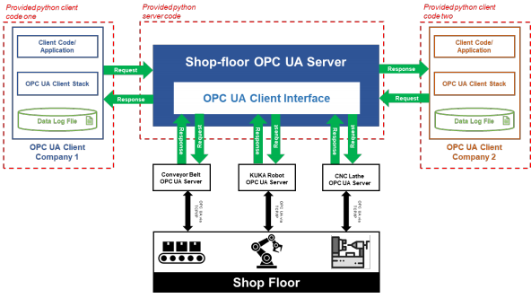
Figure 1: Server and clients communication based on OPC UA

These three pieces of machinery are working together to handle the abovementioned parts. The information of the parts is shown in Figure 2. Three different operations have been pre-defined for each part:
• Operation A: Conveyor Belt (transfer) → KUKA Robot (pick up & drop off) → Lathe (1. Turning; 2. Drilling)
• Operation B: Conveyor Belt (transfer) → KUKA Robot (pick up & drop off) → Lathe (1. Turning; 2. Threading)
• Operation C: Conveyor Belt (transfer) → KUKA Robot (pick up & drop off) → Inspection station

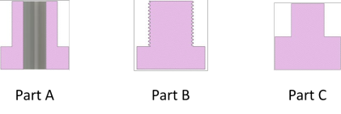
Figure 2: Parts to be produced
The OPC UA server and client codes:
You will download all the provided OPC UA python codes and a question sheet from Canvas, one for the shop-floor server, and two others for the clients. The server code is complete, but both client codes are not.

To do:
Prerequisite: Follow the instructions to set up your python coding environment.
T1: Download your individual archived files from Canvas, put them into the
same folder and open this folder in your Python IDE. (see the document “Python_and_IDE.docx”)
T2: Answer the questions listed in the “OPC UA assignment_question
sheet.docx” . You can work on this file directly.
T3: Study and understand the codes, then complete the client codes (Company1_Client.py and Company2_Client.py). All the to-do codes have been marked with # TODO, insert your codes by replacing the asterisk (*).
T4: Run all the codes on your PC. You need to run the server code
(OPC_UA_Server.py) first, then “Company_1_Client.py” . Wait for all the operations are DONE from Company 1, before starting “Company_2_Client.py”.
T5: Generate a pdf version of your completed answer sheet, save your completed client code in .py format. You should re-name them as:
Group_{group#}_Answers.pdf
Group_{group#}_ Company1_Client.py
Group_{group#}_ Company2_Client.py

T6: Logged files.
When you successfully run the code, and all the operations from both companies have finished, you should have FOUR .txt files automatically generated by the program, these are the logged data from the shop-floor OPC UA server. Save all these .txt files into the same folder (don’t make a sub-folder for them), and re- name them as:
Group_{group#}_Progress_Client_1.txt
Group_{group#}_Progress_Client_2.txt
Group_{group#}_Machine_Status_Client_1.txt
Group_{group#}_Machine_Status_Client_2.txt

Submissions:
You should put all the submission files into one folder; please do NOT make a sub-folder in your submission folder. Then, zip them into one file, i.e.

Group_{group#}_Answers.pdf Group_{group#}_Company1_Client.py Group_{group#}_Company2_Client.py | 6 Marks
Group_{group#}_Progress_Client_1.txt Group_{group#}_Progress_Client_2.txt Group_{group#}_Machine_Status_Client_1.txt Group_{group#}_Machine_Status_Client_2.txt | 4 Marks

All the submissions are due at 5:00 pm Wednesday May 31.

On Python:
There are several OPC UA libraries for different programming languages
available (https://github.com/open62541/open62541/wiki/List-of-Open-Source- OPC-UA-Implementations). Some are commercial and others are open source.
The OPC-Foundation provides a (powerful) reference implementation for C#. Unfortunately, it is very complex and has limited documentation so we will not use it. The Python-based library FreeOpcUa/python-opcua (https://github.com/FreeOpcUa/python-opcua) is much easier to use. The example/assignment code can be simple but do familiarise yourself with it (and Python language) if you have not used it before.
The assignment is designed to be completed on your own computer. For that purpose, instructions and scripts are provided. These will help you to set up your coding environment and (automatically) download all necessary software libraries. It is strongly recommended to use a more advanced IDE than the one provided with the Python distribution, e.g. Visual Studio Code.
Much more information can be found on the Internet, e.g. https://www.stavros.io/tutorials/python/. Please note that you do NOT need to be a (Python-) programming expert to do this assignment.

References

1. All lecturing notes on Canvas
2. “OPC Unified Architecture” by Wolfgang Mahnke, available via the University of Auckland Library. The e-version can be downloaded, from our Libraries and Learning Services, at https://link-springer-com.ezproxy.auckland.ac.nz/book/10.1007/978-3- 540-68899-0
3. “OPC Unified Architecture - Interoperability for Industrie 4.0 and the Internet of Things” . OPC Foundation. Downloaded at https://opcfoundation.org/wp- content/uploads/2016/05/OPC-UA-Interoperability-For-Industrie4-and-IoT-EN-v5.pdf
4. “OPC Unified Architecture for CNC Systems” . OPC Foundation, July 2017. Can be downloaded after registration for free at, ttps://opcfoundation.org/developer- tools/specifications-unified-architecture/opc-unified-architecture-for-cnc-systems/

